The University of Azad Jammu and Kashmir, Muzaffarabad

Name :Alishba Zakir
Roll No: 2024-SE-02
Course: Computer Networks
Course Code: SE-2203
Lab# 4
Submitted To: Engr. Dr. Asma Javaid
Submitted By: Alishba Zakir
Date : 17 Mar, 2026

Department Of Software Engineering

Star Topology
Star Topology:
In networking, a Star Topology is a layout where every node (computer, printer, or server) is connected to a single central hub or switch. This central device acts as a server, while the other nodes act as clients.
If one computer wants to send data to another, the signal must first pass through the central hub, which then routes it to the destination.

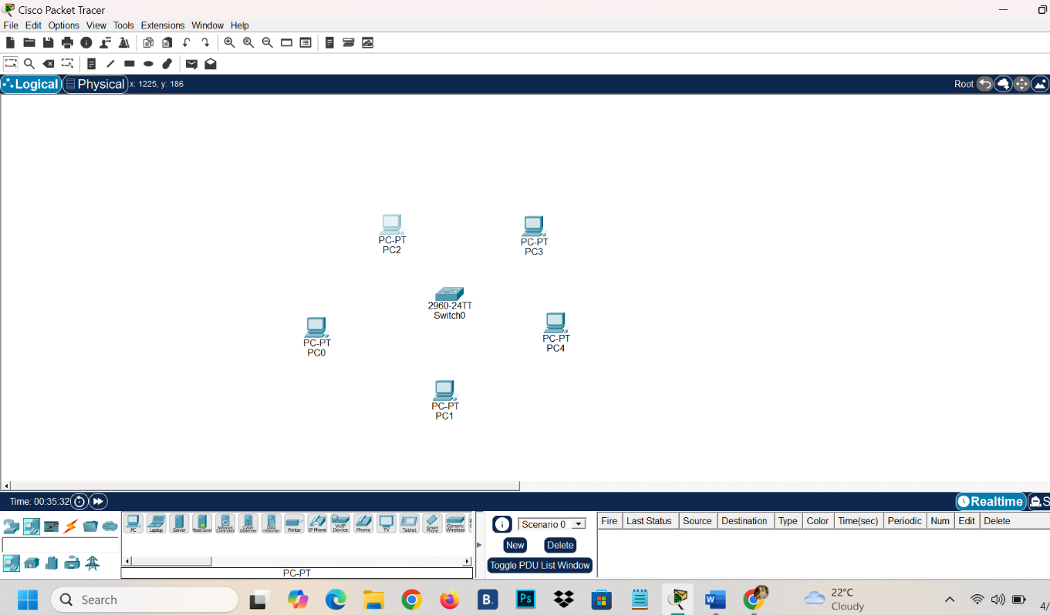

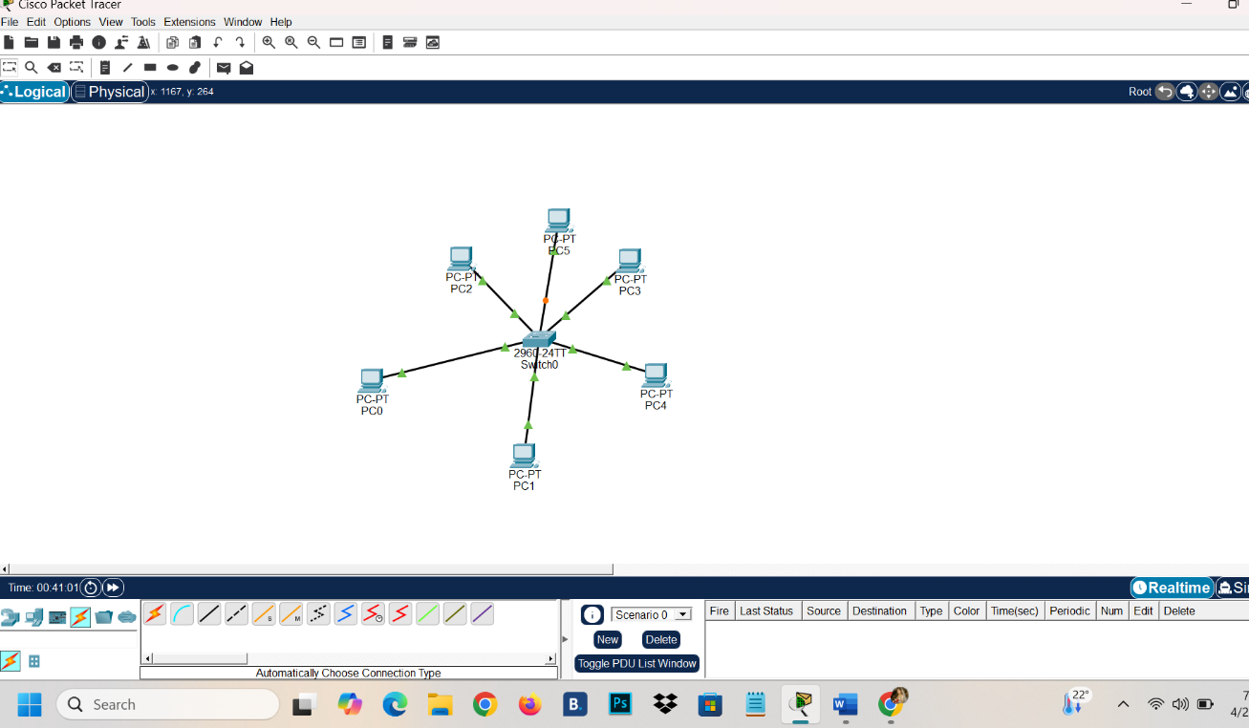

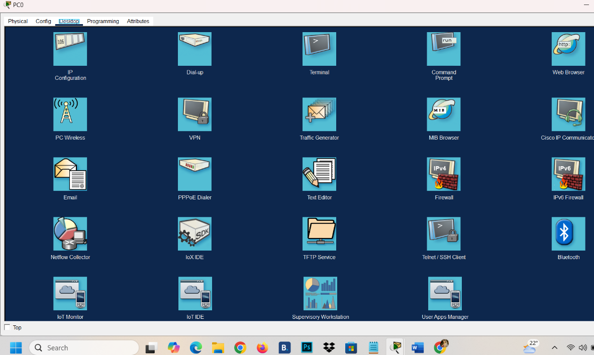

IP Configuration :
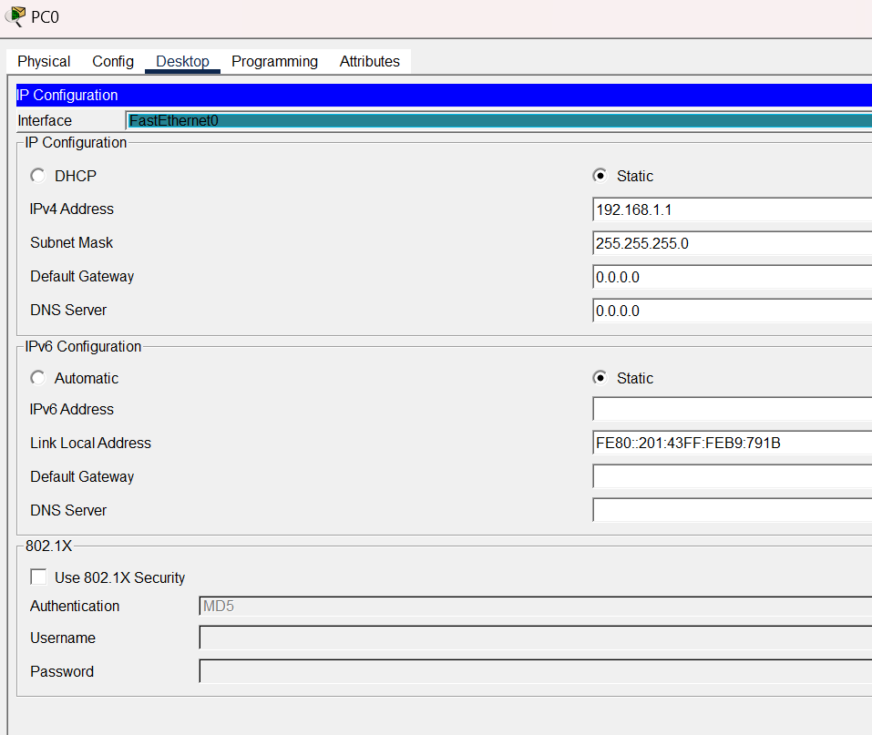
PCO

PC1
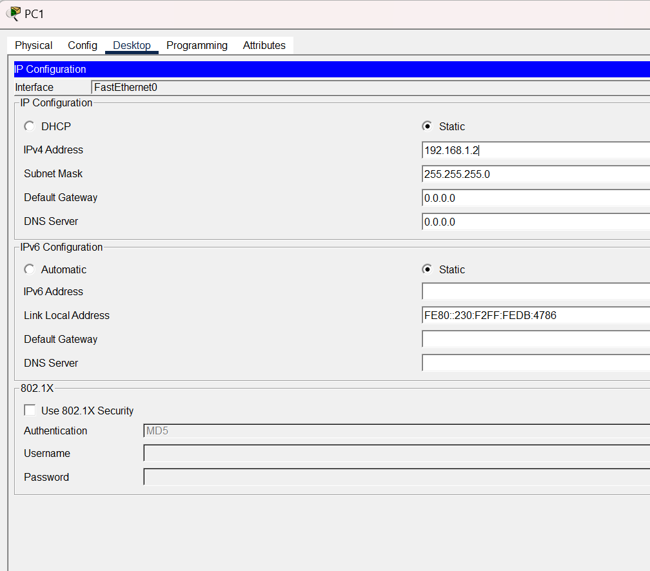

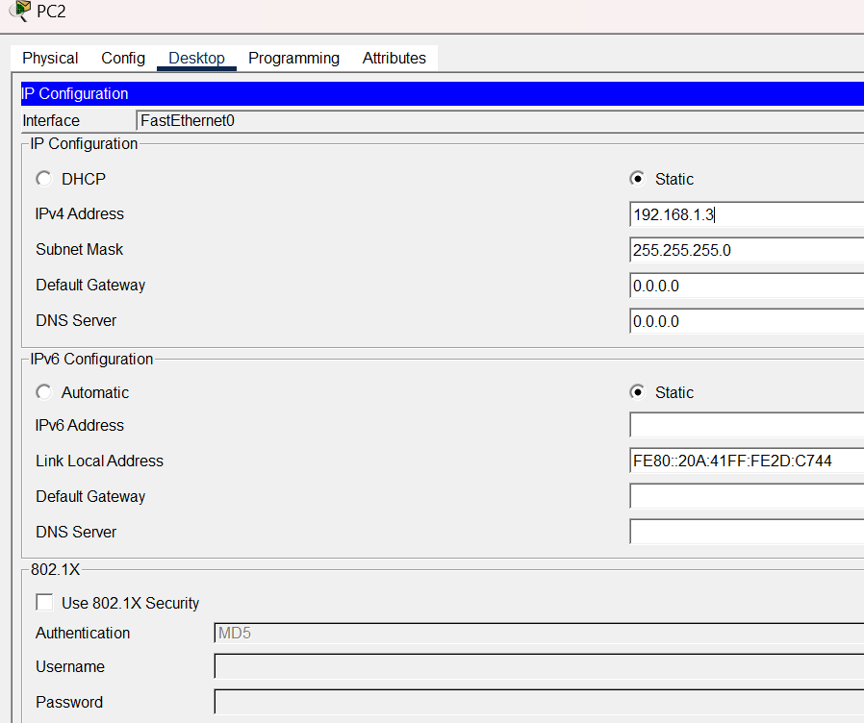
PC2

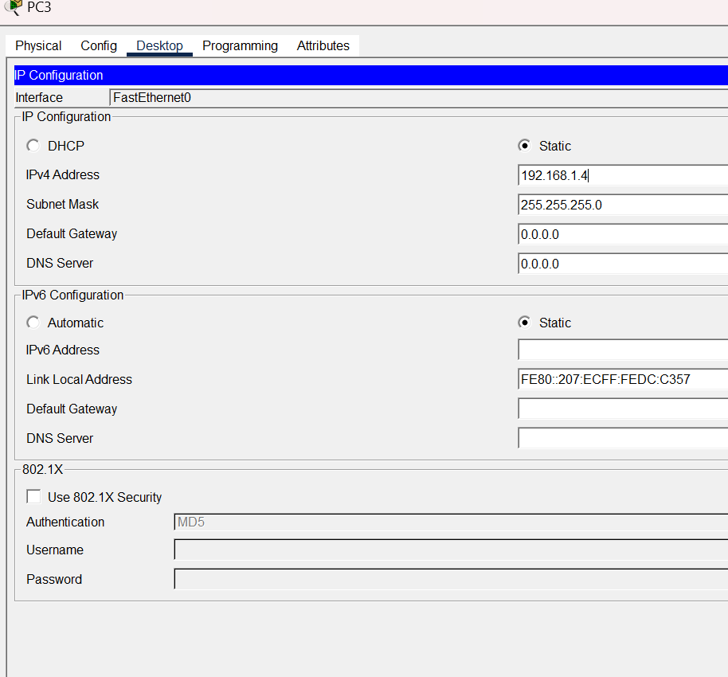
PC3
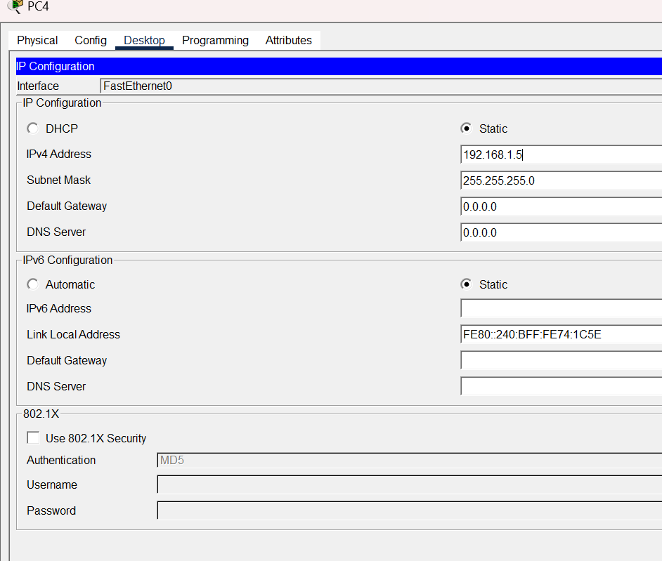
PC4

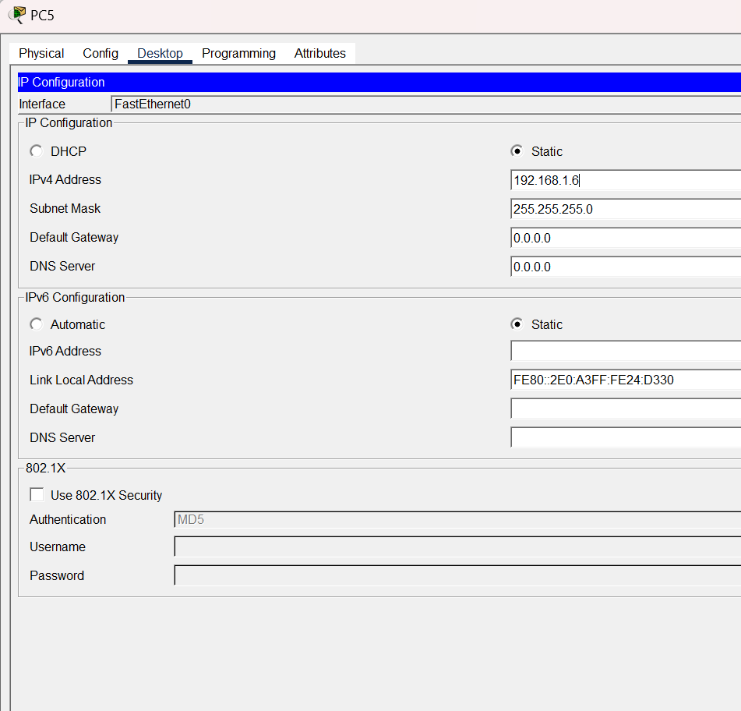
PC5
Command Prompt:

